**Scientific Training Center in Plant Biotechnology**

*Modern Plant Breeding. Beginner Level. 4th Edition . February, 6-17, 2023*

**---**

Session. 'Determining the value of genotypes through the study of

successive generations and reciprocal crosses - cytoplasmic inheritance and heterosis '

---

***CASE STUDY. Breeding program to improve the protein content in bread wheat grown under low nitrogen input conditions***

“The technological value of bread wheat is mainly based on the storage protein content and composition. A minimum content is required for export (11%) and current industrial processes are increasingly protein-intensive. At the same time, there is a downward trend in this content in national production.

The current varieties of wheat have been selected under high nitrogen fertilization, which has a strong negative impact on the environment, as well as a consequent energy cost. This type of selection is therefore no longer optimal in the current context. However, nitrogen fertilization plays a major role in yield and protein content. Indeed, the storage protein composition is determined by the amount of nitrogen in the grain.

Meeting the challenge therefore requires the creation of innovative varieties which, grown under conditions of reduced nitrogen fertilizer, show a high yield potential as well as a good quality of use. (Source: B- Dul Project - Sustainable Quality Wheat: selection of quality productive wheat under nitrogen nutrition constraints, Plant Variety Support Fund)

A seed company wants to know if it would be interesting to carry out a breeding program for the creation of a wheat variety improved for the efficiency of use of nitrogen inputs based on the cross between two of their elite varieties of bread wheat, the two pure lines Opale and E508. In addition, the company wants to obtain information on the genetic control of the quantitative character of grain protein content by studying in particular the potential existence of a heterosis effect (and more particularly of overdominance) and cytoplasmic inheritance.

To answer these questions, a comparative test in the field of the protein content (in %) of the grains of these 2 parental lines and of the early generations (F1 and F2) resulting from the cross is implemented in low N-input growing conditions. The performance of the 2 parental lines (Opale and E508), of the reciprocal F1 hybrids (F1OXE using the variety Opale as female parent and E508 as the male parent and F1EXO using the variety E508 as the female parent and Opale as the male parent) and populations in segregation F2 from the 2 reciprocal crosses (F2OXE and F2EXO) are evaluated under the same environmental conditions.

The raw protein content data for each generation is available in the 09_WheatProteinCytoplasmicHeredity.xlsx file. The descriptive and statistical analyzes of the data will be carried out with the R software. In the analysis of this case study, statistics will be used as a decision-making tool to determine whether it is interesting to continue the selection program aimed at obtaining an improved variety of common wheat for the nitrogen use efficiency of wheat from the cross between the 2 elite varieties and, if necessary, to make decisions on the strategy to be implemented to carry out this program.

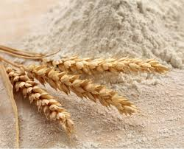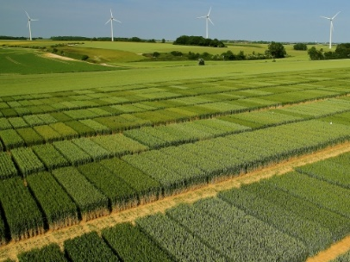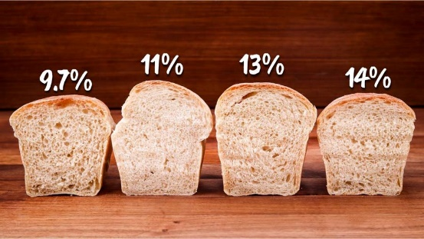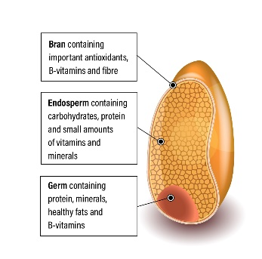

**Guidelines for analysis**

Download the dataset in .csv format to your computer from github. Above all, do not modify the file or its format! Import the data into R by writing the command below.

WheatProt <- read.xlsx( "09_WheatProteinCytoplasmicHeredity.xlsx",sheet=1)

1. *By relying on graphical representations of your data,*

* *you will discuss the quality of your dataset (ex. existence of outliers…),*
* *you will discuss the potential existence of an effect of the variety on the protein content (this effect must of course then be validated -or not- statistically! cf. Next question)*

1. *On the basis of statistical analyses, the objective of the breeder is to answer the following 3 questions in order to make the decisions that are necessary to carry out the breeding program:*

* *Is the observed difference in protein content between the 2 parent strains due to hereditary factors?*
* *Is there a overdominance effect for protein content?*
* *Is there a cytoplasmic inheritance controlling the agronomic trait of interest?*

1. *You will conduct a statistical analysis to test the effect of variety on grain protein contents.*

*After having shown that the postulates of the statistical method that you will have used are verified, you will interpret the results as to the effect of the factor studied.*

1. *After having statistically proven the significant effect of the study factor, you will continue your statistical analysis of the data by implementing a method making it possible to identify the varieties with protein contents that are significantly different from each other.*
2. *Based on the results of this statistical analysis, you will answer the 3 questions that the breeder asks himself. What does this mean for the seed company regarding the strategy to implement for the breeding program?*
3. *Calculate the broad sense heritability of the character studied and interpret.*